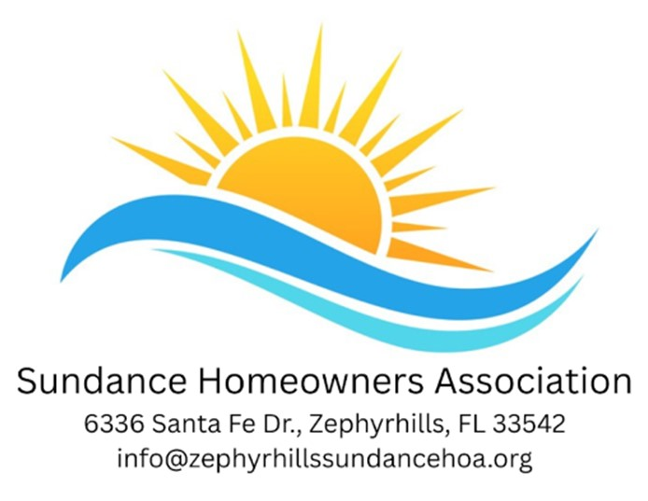
HOA BOARD MEETING MINUTES
January 13, 2026

Call to Order: 6:30 pm
Roll Call: Marilyn Custer, Anne McDonald, Kathy Oliver, Kim Dornheim, Sally Defina, Sandy Smith, April Blackman
President’s Message: Marilyn Custer reported the End of the Year President’s Report. It sums up all the HOA has accomplished. The report will be entered into our minutes. (see attached report)
Officer’s Report:
Secretary: Kathy Oliver read the minutes from the November 4th meeting. A motion was made to approve the minutes by Kim Dornheim. They were seconded by Anne McDonald. The motion was approved as read.
Treasurer: Kim Dornheim reported that as of December 31, 2025 our legal fund balance was $10,457.18. 157 households have donated to the fund so far. The financials for December have not been completed. Kim reported as of November the checking account balance was $4,101.43 and the savings account balance was $6,820.33. A motion was made to accept the financial report by Sally Defina. They were seconded by Sandy Smith. The motion passed unanimously.
Committee Report:
Finance Committee: The Financial Review Chair, Gloria Connell, read the Financial Review report to the assembly. The report was constructed with the help of the review committee, Karen Hogan, Al Dewitt, & Sally Defina. The purpose is to accurately show the finances of the association. For more information see attached report.
Activities & Entertainment: Sandy Smith reported that the following items are still to come in January. The ice cream social, the resident potluck, the comedy show, and movie night. The following are scheduled for February: A Superbowl Party, Feb 8th @ 5pm, tentatively, costing $15 per person. The HOA Board Meeting Feb 10 @ 6:30pm, proceeded by the Grill. Events scheduled are the Friendship Breakfast Buffet Feb 14 @ 10 am -noon. Price will be $15 per person, Ice Cream Social on Feb 16 @ 1 pm. Movie Night is the second in the Avatar Trilogy @ 6pm on Feb 19, Music Bingo is Feb 23 @ 6 pm & is free and will be proceeded by The Bistro @ 4:30 pm. The Vendor Fair is Feb 25 @ 9am-11am. And if available, the March movie will be Dinner & A Movie with the 3rd part of Avatar.
Sunshine Club: Ann Krauss read the names for get well cards and sympathy cards sent to this point. All names are printed in the Sundancer Newsletter for February.
Sunshine Committee: April Blackman reported that 2 meals a month, to an average of 25 residents per month, were delivered during the past year. A big thank you for all your help and unwavering support.
Safety: Ray Ball is unable to attend. The front exit gate is broken, due to being hit by a car, so be extra careful. No patrol is to go out alone.
FMO: Marilyn Custer reported that senate bill 594 is to assist low- income renters on leased land. House bill 703 made it through the house but needs to make it through the senate. It defines the rules about your rights. Please contact your state representative.
Veteran’s: Mark Jurgens, spoke for the Veteran’s. The Memorial Garden is fine, but we need some of the younger residents to step up and help with weeding & planting and generally maintaining the gardens. Also, the US Veteran’s Flag Project is having the veterans put up a flag, pole, and mounting bracket for FREE. This project is on a first-come, first-serve basis and is for a limited time and a limited number of households. The accompanying notice is in the February issue of the Sundancer. Contact Mark with any questions (317) 409-8749.
Recognition: Marilyn Custer took the opportunity to commend many residents for their support & help to the HOA during the past year. The assembly were pleasantly surprised, stating that they had never been recognized for their help in all the years they’ve lived here.
Old Business: Please listen to the recordings that have been put out for those not able to attend the community meeting. All the information you are asking for is in the recording.
It was reiterated that the new membership dues for 2026-2027 are: 15$ per person, $10 for 80+ yr olds., Free for 90+ yr olds. (with proof)
New Business: The Annual Election is scheduled for Tuesday Jan 27, 3-6 pm in the library. You must be the designated voter and have your 2025 membership card as proof of membership. If you can’t find yours, see Kim Dornheim for a duplicate card.
Karen Hogan, the nominating chair, turned in 6 signed nominating forms to Kathy Oliver, the secretary. The following names were submitted for nomination: Marilyn Custer, Sandra Smith, April Blackman, Kathy Oliver, Gloria Connell & Jill Woods.
Entertainment Pass: It was put to the membership to think about an entertainment pass. At a cost of $10 per person, per month would be entitled to one (1) event, a month at no additional cost to them. It would include food and entertainment. You can pay yearly, monthly, or have it automatically deducted. There will be a snowbird pass. If you choose not to join, the cost of each event would remain the same, $15-$20 per person, per event.
Legal update: Attorney Jeremy Anderson, was in our park over the Christmas break. He was anxious to meet Marilyn face-to-face and see what exactly he’s helping us fight for. The mediation paperwork has aa been signed and filed. It will be 30+ days until we hear back on our filings.
Last Comments: On Monday, January 26, @ 11 am-1pm come to the clubhouse and the board members will be there to assist you in singing up for the FMO. And you can renew your HOA dues as well.
Bill Schramm volunteered to be the chair of the Audit Committee. He then asked who can vote from each house. Answer: one (1) vote per household.
These minutes are proposed and will be posted on the bulletin board, then read and voted on at the February 10th meeting.
Adjournment: 7:57 pm
The Annual Election will be: January 27, 2026 @ 3 pm
The Annual Meeting will be: January 27, 2026 @ 7 pm
The next Board Meeting will be: February 10th, 2026

Respectfully submitted,
Kathy Oliver, Secretary

